BSC – HGP - Assignment 01

Stock Trade Profit Calculator

UI Design Document

# Instructions

**Submission:** Edit this template and include it as part of your submission.

**Length**: Should be 4 pages approx. Word count is flexible, but all decisions should be clarified.

To achieve good marks ensure that this document is well structured and addresses each of the following headings and subheadings. The explanation of each UI Design Choice should be clear, precise and show substantial consideration has been made, references are welcome. All decisions should be explained regardless of how basic they are. Do not cut and paste justification from the internet (plagiarism) or notes, include references and explanations in your own words where appropriate.

**Student Name:** Oguz Sarac

**----------------------------------------------------------------------------------------**

**This application is designed by just using PyQT5 Library.**

**My Works:**

What I planned before I started:

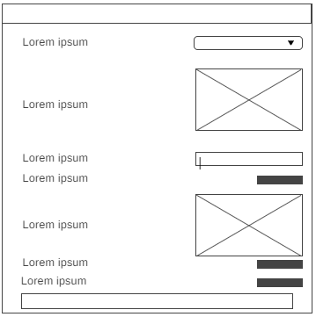

End of my work:

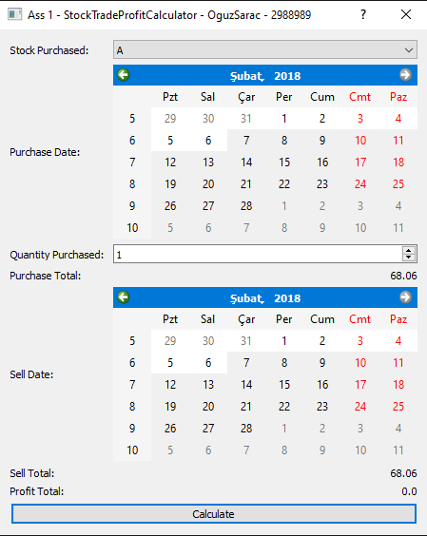

On my Assignment01 work, I totally focused on the to-do list that our lecturer gave us. All my works in this Assignment I tried to do in three features: **Present, Function, Well Designed**.

My Main aims were to keep the application (Calculator) as in **Good GUI Traits:**

1. React almost immediately which is **Responsive.**
2. Do not need a manual to use it which is **Intuitive.**
3. There is no ambiguity about what the application will do which is **Clear.**
4. The application will tell the user what it is doing which is **Informative.**
5. If the user makes a mistake the GUI will help the user recover from it which is **Forgiving.**

I tried to have a basic and understandable design from anybody. I mean age of the users of this application could be in wide range. I did some research about Stock-Trading *(https://www.elitetrader.com/et/threads/what-is-the-average-age-of-a-trader.6581/)* People are saying that there is no limit for the age because some people are earning money from that, some people are trading as a hobby and so on… So, then I said to myself, why I need to keep it simple? In these days, everybody can use a computer( at least press the turning-on button 😊 ) and sometimes, old-generation(+65) saying that they are struggling with using technological devices. That is because, I kind of designed in old-school. Calendars were the taking the important part because there was an interaction between user and the application for choosing a date. I will explain each section by section.

**Location:**

**Stock Purchased**



Here is the ‘purchase’ that I created for ‘Stock purchasing’ section. Basically, I created a QComboBox and I added items which are the stocks inside of QComboBox.

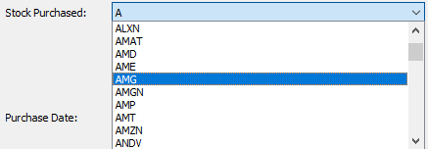

Here is another angle for QComboBox. All stocks are listed inside.

**Purchase Date**

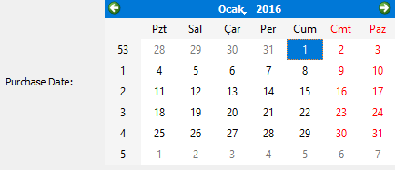

Here is the ‘Purchase date’. I used a QCalendarWidget for it. As in the given from .csv files years are limited 2013-2018. User is not able put anything newer or older year than that. For language of calendar (The months) is changing as user devices language settings.

**Quantity Purchased**



Here is the ‘Quantity Purchasing’. QSpinBox used for this section. User is deciding how many stocks that will buy.

**Purchase Total**



Showing the equality as is cost for the total stock purchasing.

**Sell Date**

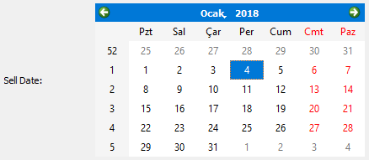

Same principle with ‘Purchase Date’. I used QCalendarWidget again in here also. User will select which day,month,year will select his/her stocks.

**Sell Total & Profit Total**



Profit total is basically, sell total – profit total all numbers are in float and Sell Total is calculating how much you selling as in total.

**Calculate**



I used a QPushButton for ‘Calculate’ button.



The function that will run when the calculation button is pressed is set and It will do the calculation in this Function.

**Size:**

For sizing I tried kept them as same much as possible. Because it will help me to prevent confusion for the users.

For QComboBox:

elf.stockPurchasedComboBox.setFixedWidth(320)

For Calendars QCalendarWidget:

self.sellDateCalendarWidget.setFixedWidth(320)

For Quantity QSpinBox:

self.stockQuantitySpinBox.setFixedWidth(320)

**Style:**

*extra feature I did a using the QHBoxLayout, QVBoxLayout Horizontal-Vertical Layout.

Button also added also bottom of the application.

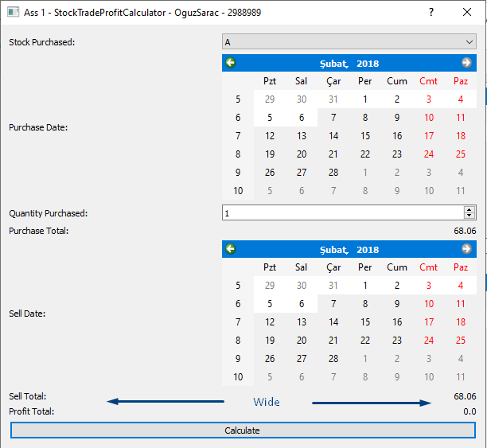

**Color:**

For the color. I tried to high contrast for the visually impaired. (Etc. On calendar weekends are red colored for the get user’s attention.)

**In Summary:**

I gave my effort on design the application for everyone. When I design something, I learn that from this module is never look in one scope of a problem. Always think about other ways and develop it. I believe I show all my work in this Assignment.